Important Visit and Payment Information for Your Telehealth Visit

Preparing for your video visit is easy!
Before your appointment:
- Check your email for sign-up link to MyChart patient portal
- If using a mobile device, download MyChart and Teladoc apps (see below)
- Complete eCheck-In prior to your visit up to 7 days before your appointment
- Log-in to MyChart to start your video about 10 minutes early to make sure you can connect

Steps for Accessing your Telehealth Appointment:
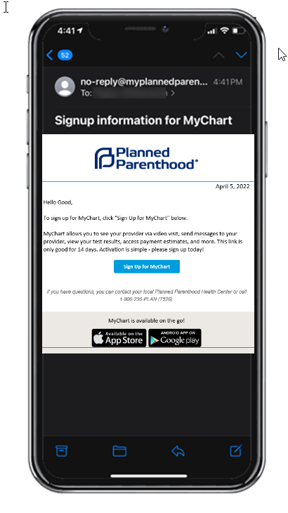
Important: please allow plenty of time before your telehealth appointment starts to complete the MyChart registration and eCheck-In steps.
- All patients need to sign-up for Planned Parenthood’s patient portal, MyChart to complete a telehealth appointment.
- A link will be sent to the email address you provided prior to your appointment with instructions on how to sign up for MyChart. This link will arrive shortly after you schedule your appointment with the subject line “Signup information for MyChart.” The link is good for 14 days and then will expire.
- Follow the steps in the email message to begin the registration process:
- You can access MyChart via the web or a mobile app. It is recommended that you download the MyChart app if you are using a mobile device. It is easy and free!
- Create a username and password of your choosing and enter your date of birth. Click Submit.
Please allow enough time before your appointment start time to complete the eCheck-In process once your MyChart account has been activated. You will not be able to access your telehealth appointment until the eCheck-In process is completed. Some patients may need to provide full medical history information, which can take a bit more time to complete.
After starting your telehealth video visit, MyChart will then refer you to Teladoc for your telehealth appointment:
- Mobile: The Teladoc Health Patient app (available on App Store for iPhone), OR the Teladoc Health app (available on Google Play for Android)
- Desktop: Teladoc, through Chrome or Firefox browsers.
We’re here to help. If you have issues connecting with your provider on MyChart, call us at 215-351-5550
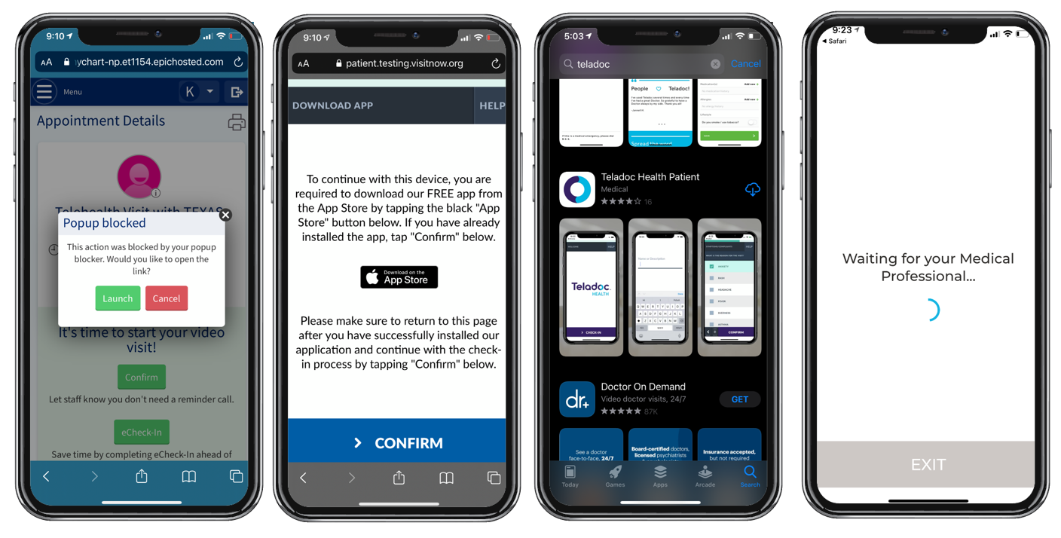
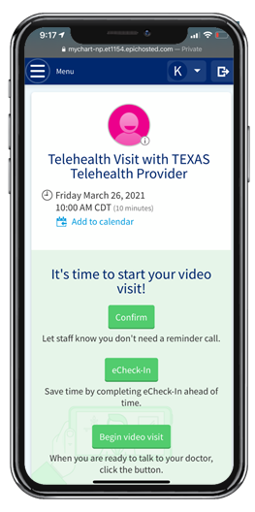
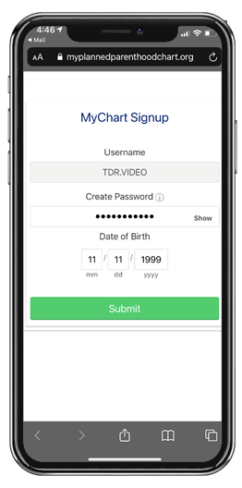

Payment is required prior to starting your telehealth video visit.
- We accept commercial insurance, PA Medicaid and Self-Payment
- For insurance, we will collect your co-pay before the visit within MyChart
- For self-pay, we will collect our best estimate of your fee before the visit within MyChart. Please note: our fees are charged on a sliding scale (based on household income). We may contact you via phone to review charges.
- For uninsured patients, you may qualify for subsidized services, please ask our staff and/or apply at http://www.compass.state.pa.us/
- Your payment must be made by credit or debit card.

We’re here to help. If you have issues connecting with your provider on MyChart, call us at 215-351-5550
Important PAYMENT Information

