HOW TO GIVE YOURSELF A HORMONE INJECTION – INTRAMUSCULAR (IM)

Dose you have been prescribed | Amount you should draw up into the syringe
 | mL/cc

Video guide
PP Greater Texas has developed video guides for self-injection instruction. These videos are available in English and Spanish and can be accessed at plannedparenthood.org/planned-parenthood-california-central-coast/patient-resources/gender-affirming-care/self-injection-videos. Video transcriptions are also available for download on the website.

What is an intramuscular (IM) injection)?
An intramuscular injection is a way of injecting medication deep into the muscle tissue. This allows the medication to be quickly absorbed into the bloodstream. Intramuscular shots are given at a 90° angle with the needle going straight through the skin into the muscle.

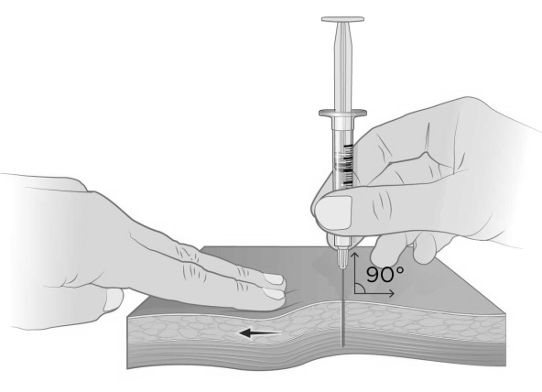
What do I need for an IM injection?
To give yourself an IM injection, you will need:
• Medication in a vial
• 1 disposable syringe
• 2 needles
o 1 18 or 20 gauge needle to draw up medication
o 1 22 or 23 gauge needle for the injection
o Note: The needle size is described in units called
gauge numbers. The smaller the needle gauge, the
bigger the needle.
• 2 alcohol swabs (1 for vial & 1 for skin)
• Cotton ball or gauze
• A special, puncture-proof container to throw out the used needles and syringe (sharps container).

How do I get the needles and syringes for an IM injection?
You can get needles and syringes from PPCCC during your visit or from a local pharmacy.

NEVER REUSE OR SHARE SYRINGES OR NEEDLES. If you need needles or syringes and cannot afford to get them from PPCCC or your pharmacy, please visit a local syringe access program.

Step 1: Set up your injection work area
1. Find a comfortable, well-lit place to give yourself your injection.
2. Clean your work area and assemble the supplies listed above.
3. Check the expiration date on the medication. Do not use your medication if it has visible particles, is discolored, or is expired.
4. Wash your hands with soap and warm water or an alcohol-based hand cleaner. Hand washing is one of the most important things you can do to prevent infection.

Step 2: Prepare your injection dose
1. If you want, you can warm the vial of medication by rubbing it between your hands before preparing the syringe. This may help with some discomfort during the injection.
2. Take the cap off the vial. Clean the rubber stopper with 1 alcohol swab and let it to air dry.
3. Check the package containing the syringe. If the package has been opened or damaged, do not use the syringe.
4. Hold the 18 or 20 gauge needle by the packaging or the cap and place it securely on the syringe. Do not touch the base of the needle that attaches to the syringe.
5. Pull the 18 or 20 gauge needle cover straight off the syringe.
6. Pull back the plunger and draw air into the syringe. The amount of air drawn into the syringe should be the same amount (mL or cc) as the dose of medication that your clinician prescribed. Do not let the needle touch any surfaces!
7. Set the vial on your working space, with the rubber stopper facing up, and insert the needle straight down through the center of the rubber stopper into the bottle (see Figure 1).
8. Push the plunger of the syringe down and push the air from the syringe into the vial.

9. Keeping the needle in the vial, use your other hand to turn the vial upside-down. Do not let go of the vial!
10. Position the needle so the liquid is covering the tip of the needle.
11. Keep the vial upside-down and slowly pull back on the plunger until the syringe is filled with the number (mL or cc)
that matches the dose your clinician prescribed you. As you remove the medication from the vial, the level in the
bottle decreases. You may have to lower the needle below the fluid level to draw up as much medication as you need
(see Figure 2).
12. Keeping the needle in the vial, check for air bubbles in the syringe. If there are air bubbles, gently tap the syringe with your fingers until the air bubbles rise to the top of the syringe. Then, slowly push the plunger up to force the air bubbles out of the syringe without removing the needle from the bottle (see Figure 3).
13. After air bubbles are gone, pull the plunger slightly past the number (mL or cc) on the syringe that matches your dose.
14. Pull the syringe with needle out of the bottle.
15. Remove the 18 or 20 gauge needle and put it into the sharps container without recapping it.
16. Hold the 22 or 23 gauge needle by the packaging or the cap and place it securely on the syringe. a. Do not touch the base of the needle that attaches to the syringe.
b. Do not remove the protective cap from the needle until you are ready to inject.
17. Gently push the plunger to the number (mL or cc) matching your dose, making sure that you have the correct dose in the syringe. It is very important that you use the exact dose prescribed by your clinician.

Figure 1 | Figure 2 | Figure 3

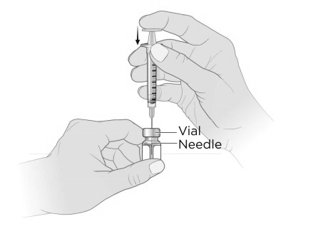
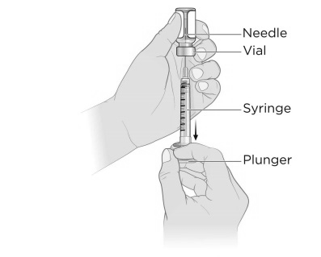
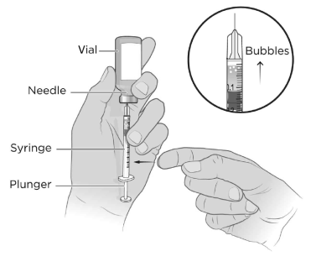
Step 3: Select and prepare injection site
1. There are two areas you can pick for your injection site:
a. Thigh muscle, also known as the vastus lateralis (see Figure 4)
b. Hip muscle, also known as the ventrogluteal muscle (see Figure 5)
2. The upper thigh is a good site if you are injecting yourself. If you want to use the hip muscle, you will need to get help from someone else.
3. If you want, you can apply ice or an over-the-counter numbing cream to the injection site before cleaning it. This may help with discomfort.
4. Wipe the area where you plan to give the injection with a new alcohol swab and let air dry. If you do not let it air dry, it might cause stinging during the injection.
5. Do not touch this area again until you give the injection.

Figure 4 | Figure 5

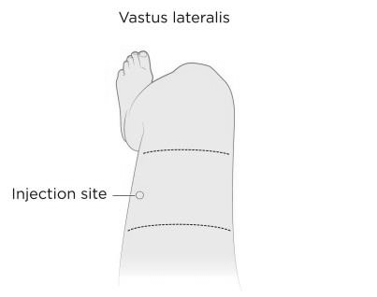
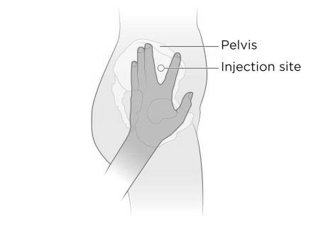
Step 4: Administer the injection
1. Remove the protective cap from the injecting needle and check one more time that the correct dose is in the syringe.
2. With your other hand, use your thumb and index finger to push/spread and hold the skin taut around the injection site
(see Figure 6).
a. Leave about 2 inches of space between your fingers.
b. The skin between your fingers will be the injection site.
3. Hold the syringe barrel tightly and use your wrist to insert the needle all the way through the skin and into the muscle

at a 90° angle.
a. Try to keep your muscles warm and relaxed during the injection. This may help with any discomfort. b. Push the needle through the skin in a smooth, single motion. Try not to hesitate.
c. Do not push the needle into the skin slowly or thrust the needle into the skin with a lot of force. d. Do not press down on the top of the plunger while piercing the skin.
4. To inject the medicine, push down on the plunger slowly.
a. Do not force the medicine by pushing too hard.
b. You may feel some burning or pressure as the medication enters the muscle.
5. After injecting the medication, pull the syringe at the same angle it went in to remove the needle from your skin.
6. Put the used needle and syringe into the sharps container to dispose of it (see Figure 7 & Figure 8).
7. Gently press a cotton ball or gauze on the injection site. a. Hold pressure on the site until the bleeding is done. b. You can use a band aid if necessary.

Figure 6 | Figure 7 | Figure 8

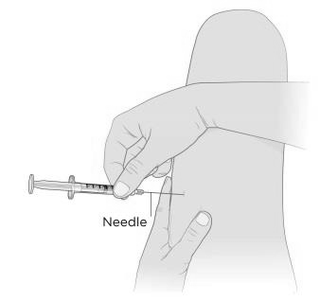
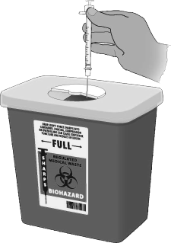
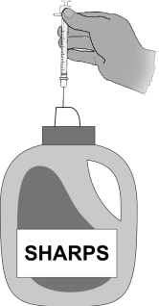
Step 5: Dispose of the needles and syringe
1. All sharps (needles and syringes) should be disposed of in a sealable, puncture-resistant container. a. You can get a home sharps container from most drugstores (see Figure 7).
b. You can also use a plastic container, like a laundry detergent bottle or milk jug (see Figure 8). If you do, the bottle or jug you use must have a lid.
2. You can use the same container for your sharps until it is about ¾ of the way full.
3. When your sharps container is ¾ of the way full, tape it shut and label it “syringes,” “sharps,” or “needles.” Most home sharps containers are pre-labeled, but if you use a detergent bottle or milk jug you will need to label it yourself.
4. After your sharps container is taped and labeled, you can put it in the regular trash. Do not put it in the recycling.
5. If you need more information about how to dispose of your syringes, call 3-1-1 for help.

Contact information
If you have any questions call (888) 898-3806 or email gac@ppcentralcoast.org
San Luis Obispo Health Center | Santa Barbara Health Center | Santa Maria Health Center
743 Pismo St.  San Luis Obispo, CA 93401 | 518 Garden St.  Santa Barbara, CA 93101 | 415 E. Chapel St.  Santa Maria, CA 93454
Thousand Oaks Health Center | Ventura Health Center
1200 W. Hillcrest Dr.  Thousand Oaks, CA 91320 | 5400 Ralston St.  Ventura, CA 93003

