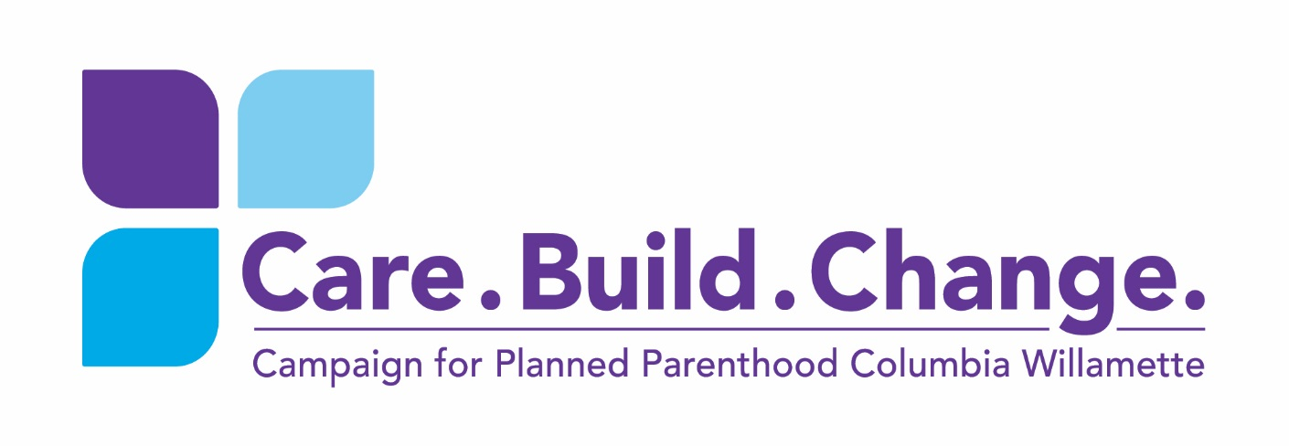
$
I/We are pleased to give/pledge/recommend
This gift is made in the belief that the work of Planned Parenthood Columbia Willamette is essential for the health and well-being of our community.

Donor Information:
Name/Contact:
Foundation/DAF:
Address:
City:
State: |  | Zip:
Phone:
Email:

- Please keep this gift anonymous

Gift Designation: Please check all that apply and specify what percent of gift
- The S.E. Portland Health Center project _________%
- The Education Endowment for PPCW invested with the Oregon Community Foundation _____%
- Campaign costs _________%
- Where the campaign needs it most _________%

Payment Method:
Please make checks, corporate matches, and stock transfers payable to PPCW
at 3727 NE Martin Luther King, Jr. Blvd., Portland, OR 97212
- Cash/Check
- VISA or MasterCard:
Account #: |  |  |  |  | Expiration Date | / /
CSV: |  |  | Signature:
- Electronic Transfer
- Online at www.plannedparenthood.org (Please click on Donate and select PPCW under the Specific Giving tab’s “Organization” drop down menu)
- Stock (Fill out stock form for your broker)

(over)

Gift Fulfillment:
- Outright gift by ____/___/_____ (date)
- Payments of $____________ monthly/quarterly/annually (circle one)
  - For annual payments: in which month can we expect your payment (or process your credit card, if applicable)?: ______________

Monthly credit card payments will be processed on the 1st of each month; quarterly payments on the 1st of March, June, September and December; annual payments on the 1st of the month listed above.

Tribute:
In Memory of:
In Honor of:

Matching Gift:
This gift will be matched by my employer:

- I/we understand that this agreement is intended to be binding and enforceable against me/us and my/our estate, heirs, successors and assigns.
- I/we will recommend my Donor Advised Fund to make this gift.

___________________________________________________ Date__/__/____
Donor Signature(s)

___________________________________________________ Date__/__/____
Donor Signature(s)

___________________________________________________ Date__/__/____
Anne J. Udall, President and CEO, PPCW

Thank you for your generosity.

PPCW is a 501c3 organization. Our tax ID # is 93-6031270. This gift may be tax-deductible. Please contact your financial professional before making a gift or pledge.

The Donor agrees to allow PPCW and PPFA to recognize this gift in publications and at events unless anonymity is specified.

3727 NE Martin Luther King Jr., Blvd. | Portland, Oregon 97212 | Kim Thompson, 503-280-6157

