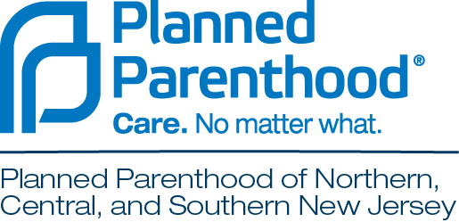

2019/2020 Advocates Alliance
Grant Application

Planned Parenthood was founded on the revolutionary idea that all people should have the information and care they need to live strong, healthy lives and fulfill their dreams. Planned Parenthood of Northern, Central, and Southern New Jersey’s (PPNCSNJ) Advocates Alliance is investing in local projects that advance this mission and reflect local initiatives that support the delivery of vital reproductive health care, sex education, and information to women, men, and young people in NJ. Projects can range from health care delivery and education to advocacy and research. Competitive grant applications will focus on projects empowering NJ communities to challenge the status quo, build their leadership, and lead positive change in areas that reflect PPNCSNJ mission. We also encourage applicants to learn about SisterSong’s reproductive justice framework and apply this lens to their work. SisterSong defines reproductive justice as the human right to maintain personal bodily autonomy, have children, not have children, and parent children in safe and sustainable communities.

Grants are funded by a special initiative from the PPNCSNJ Board of Directors and administered through the leadership of the PPNCSNJ Advocates Alliance. Learn more about the Advocates Alliance at aa.ppncsnj.org.

Grants awards range between $5,000 and $15,000. At this time, these are one-time grants and recipients are not guaranteed funding for future years.

ELIGIBILITY REQUIREMENTS
- The organization or program must be focused in PPNCSNJ’s service area, which covers the state of New Jersey, with the exception of Essex, Hudson, and Passaic Counties.
- The funding year for the program supported by the grant is October 1, 2019 – September 30, 2020.
- Organizations must have documented 501(c)(3) status.
- Organizations must have an annual operating budget under $5 million.
- Organizations may have a religious affiliation, but the project seeking funding may not proselytize.
- Grants will not be given for reserve funds, debt retirement or operating deficits, indirect expenses unrelated to the project or program being funded, sponsorship of fundraising events, endowments, capital projects, political elections, or other requests that do not reflect the goals of this initiative.

TO APPLY
Please email your completed application and attachments, no later than Friday, August 30 at 5:00PM, to AdvocatesAlliance@ppgnnj.org. By submitting an application, you are certifying that you meet the eligibility requirements listed above. Grants will be awarded at the end of September.

2019/2020 Planned Parenthood of Northern, Central and Southern NJ Advocates Alliance Grant Application

Organization Name:
Amount of Grant Request:
Contact Name:
County/Counties Served By Grant:
Organization Address:
Organization Email:
Organization Phone:
Organization Website:
Organization Annual Operating Budget:
(Please attach a copy of your organization 501c3 IRS letter, 990, list of current board of directors and project budget.)

- In detail, provide a short overview of the program for which you are requesting support and describe the demographics and needs of the community you aim to serve.

- How will this program impact reproductive health care and sexual health via health care delivery, education, advocacy or research? In detail, please outline your goals and project plan.

- How will you work to deepen your relationship with Planned Parenthood during this grant period?

- Describe how will you operate your program from a reproductive justice lens?

- How will you define and measure success?

- Please outline how the grant funds will be used below or attach a project budget.

Learn more at https://www.sistersong.net/reproductive-justice/

