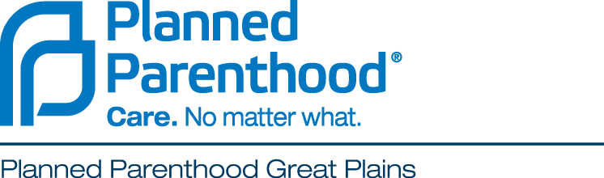

How to Include Planned Parenthood Great Plains
in Your Estate Plans
Planned Parenthood Great Plains is dedicated to upholding the standard for providing high quality sexual and reproductive health care; providing education that promotes informed proud and authentic sexuality, and changing the culture through proactive advocacy to ensure equality in reproductive and sexual decision making. Remembering Planned Parenthood Great Plains in your estate plans is a profound and generous act that will support future generations of patients and the communities we serve in Kansas, Missouri, Oklahoma, and Arkansas.
A Gift by Bequest
Planned Parenthood Great Plains can be remembered in your will or living trust in different ways. A “specific bequest” establishes a gift of a particular dollar amount or asset. A “residuary bequest” makes a gift of all or part of the property remaining in your estate after debts, expenses, and specific bequests are paid. Your attorney may wish to include language similar to the following:

A SPECIFIC BEQUEST: “I give, bequeath, and devise (dollar amount or description of gift) to Planned Parenthood Great Plains, now or formerly located at 4401 W. 109th Street, Suite 200, Overland Park, KS 66211, to be used for its general purposes.”

A RESIDUARY BEQUEST: “I give, bequeath, and devise (all, or ____ percent of) the rest, residue, and remainder of the property, both real and personal, wherever situated, which I may own or be entitled to at my death, to Planned Parenthood Great Plains, now or formerly located at 4401 W. 109th Street, Suite 200, Overland Park, KS 66211, to be used for its general purposes.”

Your attorney may find the following legal information helpful. Please be sure your attorney includes our full legal name.

Legal Name: Planned Parenthood Great Plains
Address: 4401 W. 109th Street, Suite 200, Overland Park, KS 66211
Tax Status: Tax-exempt, 501(c)(3) nonprofit organization
Tax I.D.: 44-0565390

Page 2

A Gift through Bank and Brokerage Accounts
Even without a will or trust, you can leave a “bequest” to Planned Parenthood Great Plains through a bank or brokerage account. In most states, you can designate these funds to the charity of your choice through a beneficiary designation. Financial institutions refer to this as “Transfer-on-Death” or “Payable-on-Death” provisions. These are easy to complete, there is not a fee, and you can change your mind in the future. By filling out a form with your financial institution, assets including savings accounts, money-market accounts, certificates of deposit, securities accounts, bonds, and mutual funds, can be transferred directly to Planned Parenthood Great Plains immediately after your death. Designating these assets for a charitable organization will qualify your estate for an estate tax charitable deduction.

A Gift through Retirement Plans
Retirement funds are important to consider in your plans. Naming Planned Parenthood Great Plains as a beneficiary or contingent beneficiary of an IRA, 401(k), 403(b), or other retirement account can be a generous and smart way to provide for the future of family planning. Making a gift in this way will not affect the retirement benefits that you receive, and you will keep full control of the account. By designating Planned Parenthood Great Plains as a charitable beneficiary directly with the company that administers the account, the full value remaining in the account after your lifetime can pass tax-free, outside of probate, to Planned Parenthood Great Plains as a charitable gift.

Naming a Charitable Beneficiary
For a life insurance policy or retirement plan, your provider will ask you to complete a change-of-beneficiary form. You will need to provide our legal name, address, and tax identification number, which are listed on the first page of this letter. Please note that these assets will be directed according to the designation on the beneficiary form, regardless of what is written in your will. If you are married, you may be required to have your spouse sign a consent form for such changes. Unless you have made other provisions, we encourage you and your spouse to retain full benefits for both of your lives, leaving as a gift to Planned Parenthood only those assets that remain at the end.

Questions? Please contact:
Corrie Moore, Vice President of Development
Planned Parenthood Great Plains
4401 W. 109th Street, Suite 200, Overland Park, KS 66211
913-345-4633
corrie.moore@ppgreatplains.org

