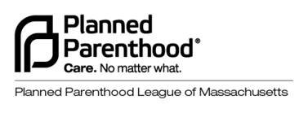
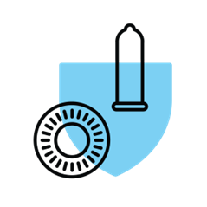

Protection Methods Demonstration Kit
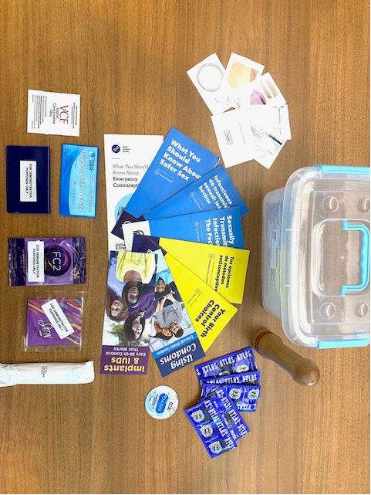
The Protection Methods Demonstration Kit is available to purchase from Planned Parenthood League of Massachusetts. For just $110 plus $20 shipping & handling, you'll get the most comprehensive resource for teaching about contraception and protection methods, contained in a heavy duty, clear plastic case designed for portability. This is the ultimate resource for sex educators to facilitate lessons on birth control, STIs, and healthy relationships.

All items are samples for display and educational purposes only.

Kit includes the following demo items*:  1 Birth Control Pill Pack Model | Kit includes the following brochures:  1 Safer Sex
1 Vaginal Contraceptive Film | 1 LGBTQ Sexual Health, when available
1 Contraceptive Gel | 1 Using Condoms
1 Sample Lubricant | 1 Implants & IUDs
1 Wooden Condom Demonstration Model | 1 Your Birth Control Choices
1 Rapid Response Pregnancy Test | 1 Tus Opciones de Métodos Anticonceptivos
10 External/Male Condoms | 1 Sexually Transmitted Infections
1 Internal/FC2 Female Condom | 1 Enfermedades de transmisión sexual (ETS)
1 Dental Dam | 1 Emergency Contraception
1 Laminated Pill Pack Image | 1 Anticoncepción de Emergencia
1 Laminated Shot Image  1 Laminated Ring Image | *Kit includes at least 1 of following: IUD insertion device, contraceptive ring model, contraceptive implant model

We try to provide every item listed here. Sometimes, due to a lack of supply of demo units from contraceptive manufacturers we are unable to provide every contraceptive method listed at the time we fulfill your order. In this case, laminated images of any unavailable items will be provided. We apologize for any inconvenience.

Please Make Checks Payable To:
Planned Parenthood League of Massachusetts
1055 Commonwealth Ave
Boston, MA 02215
ATTN: Education Dept
Protection Methods Demonstration Kit Order Form
Order Date:
PO Number:

Quantity | Item Name | Price | Total
 | Protection Methods Demonstration Kit
 |  | Subtotal
Shipping
(Free shipping with the purchase of 3+ kits)
 |  | Grand Total

Please Check Type of Payment: | ☐Check | ☐Purchase Order

Billing Address
 | Full Name
 | Street Address
 | City |  | State |  | Zip Code
 | Email |  | Phone Number
Shipping Address
 | Full Name
 | Street Address
 | City |  | State |  | Zip Code
 | Email |  | Phone Number

To Place an Order Please Email the Complete Order Form To: educationontheweb@pplm.org

Have Any Questions? Please Call Us At: (617) 616-1672 Ext: 111672 or email us at educationontheweb@pplm.org

